ABOXAN arts
  - Illustration Portfolio

aboxanarts@instagram
!Gâi tses my name is Thurston Jacobs I go by RA I
Creator and founder of ABOXAN ARTS I am a Artist, Illustrator, Graffiti Writer ,Traditional Artist, Events Organiser, Poet , Hip Hoppa, from Kraaifontein Cape Town South Africa.
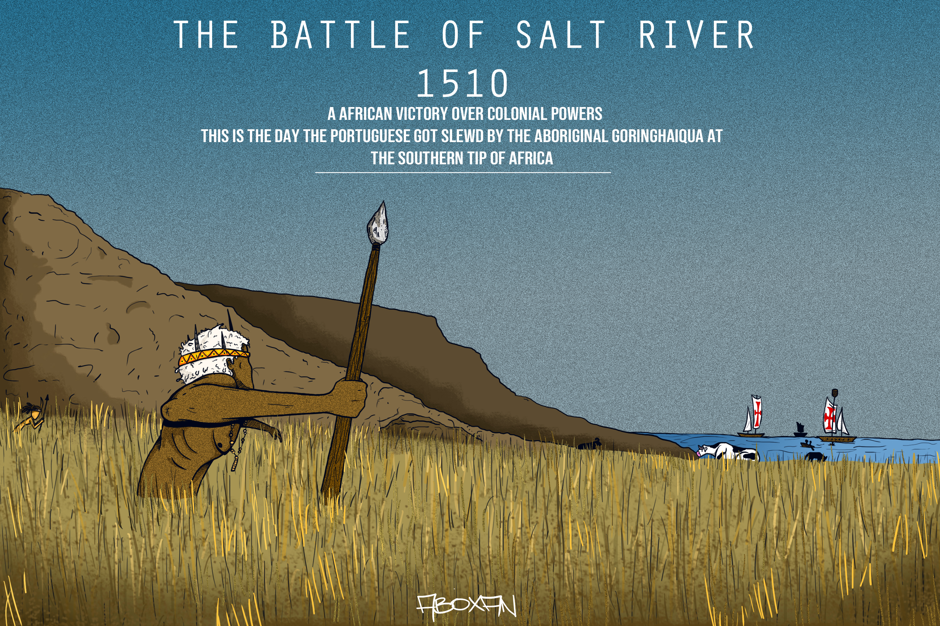
My works are focused on the Stories and realities of Africa and her cultures and people. I do many landscape and environment scenes, faces and creatures from the imagination, the past the present and future of Africa and the universe with characters and Graffiti incorporated in the stories, one of my clients I do works for calls my work Afro futuristic Art. I document life as I see it and imagine it and use my illustrations to educate and inspire people through the visuals I manifest from life experience and the imagination.
I have been a independent artist since I started my art journey in 2019 I worked with Music Artist and did some album covers to name a few KxNG K, MR Griep, Seed Of Amenti and others local South African artist. I use to do album art and graphic designs for 184Records that was a underground music label in South Africa that I was part of. I did logos and illustrations for a couple of NPOs and Private Companies such as KOS COMMUNITY GARDEN, ADWA MOVEMENT, CONQUERORS REGGAE BAND to name a few.
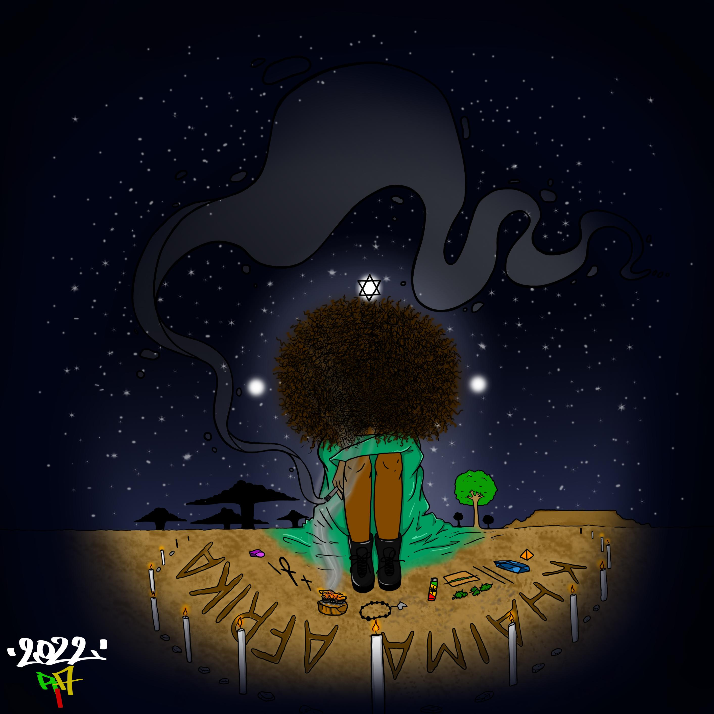
I am at the moment doing freelance illustrations for independent entities, start up companies and anyone in need of my services and I am in the progress of starting my first Pan African coloring Book for all African children on the continent and the Diaspora specifically focusing on the southern part of Africa.
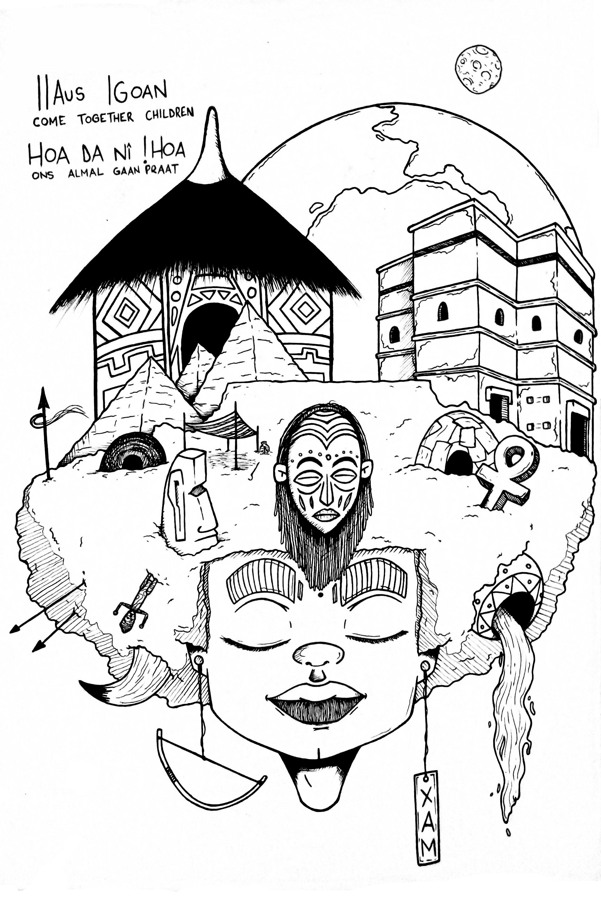
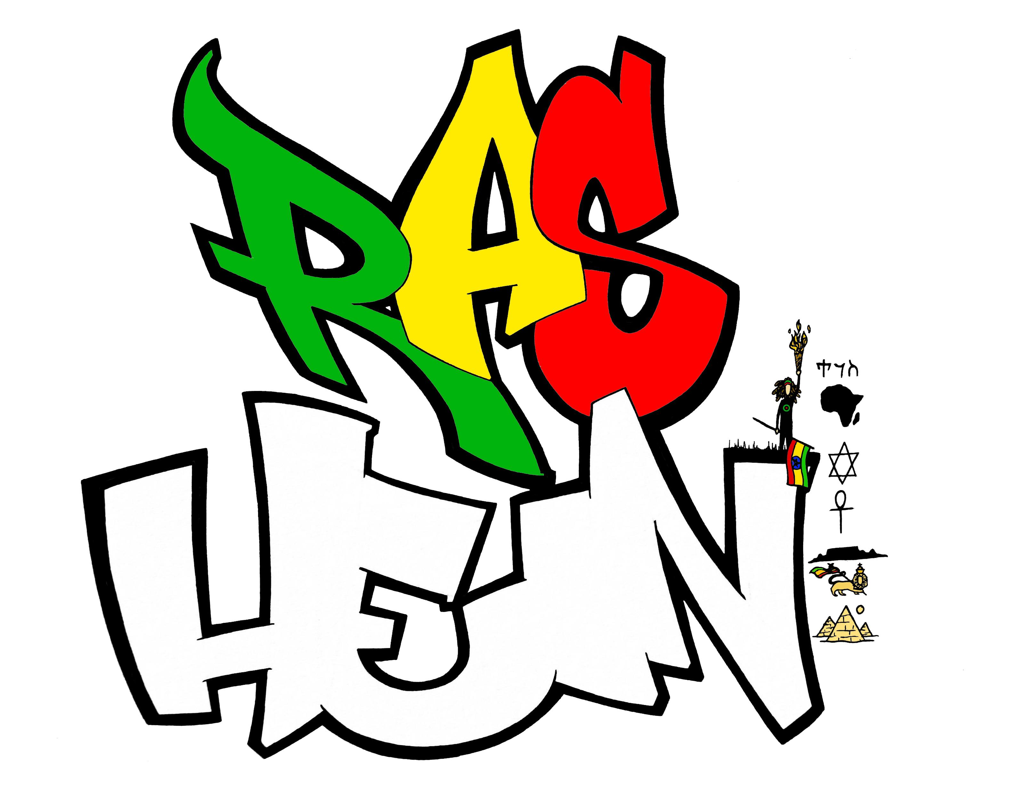
We preserve our story through the expression of what we see and what we do from that time till this time and a time to come fulljoy the journey with the ABOXAN.
